Customer Engagement & Solution Design Dashboard (Salesforce)

A Salesforce Lightning Dashboard and Automation

Nelson Anderson 07-23-2025

This project showcases a Customer Engagement & Solution Design Dashboard built in Salesforce Lightning to address a common business challenge: lack of centralized visibility into customer engagement lifecycles and feedback. In this scenario, I’ve created a tech services organization that struggles to track Engagement stages, recommended solutions, and post-implementation feedback, leading to inefficiency and inconsistent data. I designed and implemented a solution using custom objects (Customer, Engagement, Feedback), configured their relationships, and built a record-triggered Flow that automatically creates Feedback records when an Engagement reaches the Implementation stage. I also developed key reports and a Lightning dashboard summarizing Engagements by Stage, average Feedback Scores by Product, and Open Engagements by Customer, delivering actionable insights and improving operational efficiency.

**Dashboard**

This is a Salesforce Lightning dashboard created using reports that display Engagements by Stage, average Feedback Scores by Product, and Open Engagements by Customer.

**Reports**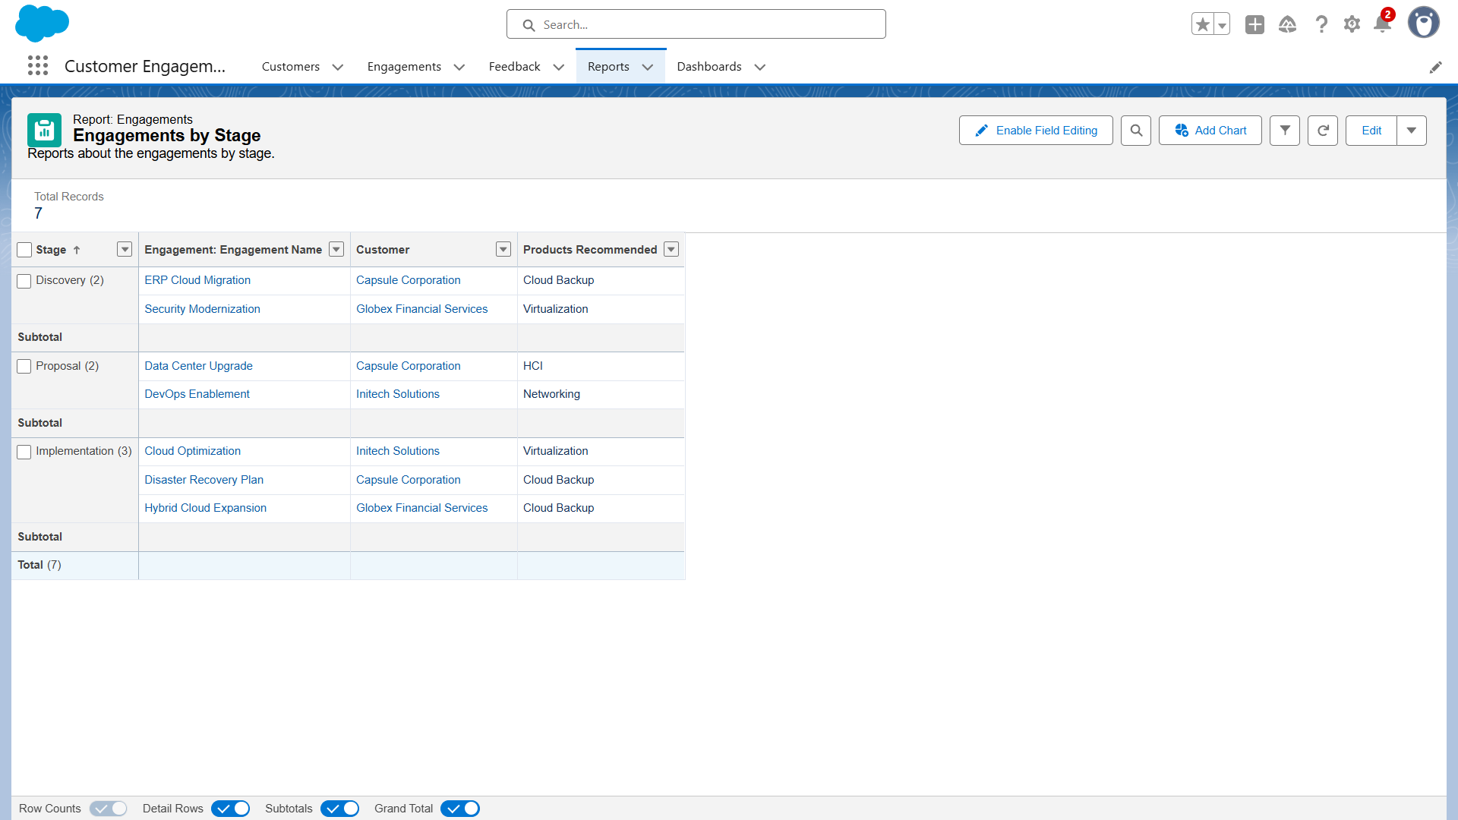

Report summarizing Engagements grouped by Stage, used for the dashboard’s pie chart.

Report showing average Feedback Scores grouped by Products Recommended, used for the dashboard’s bar chart.

Report listing open Engagements by Customer, used for the dashboard’s table component.

**

For this app, I created three custom objects to model Customer engagement and Feedback processes.

**Flow**

Record-Triggered Flow that automatically creates a Feedback record whenever an Engagement enters the Implementation stage.

**Sample Records**

Sample customer record with relationships to their engagements.

Sample engagement record and its relationship to its feedback.

Sample feedback with survey score and comments from the customer once in the implementation stage.